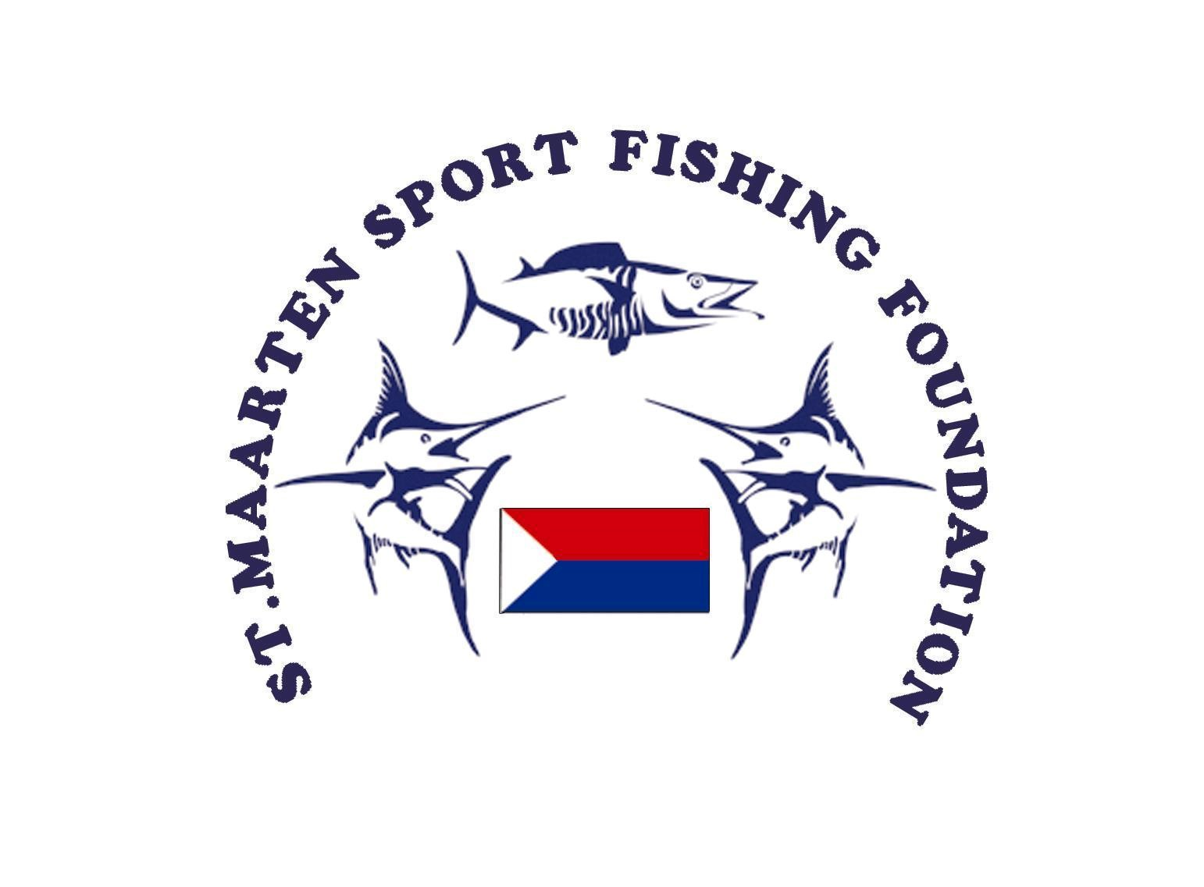

13th Annual SXM Wahoo Tournament 2024 Registration Form

Name of Boat:______________________________________ Length:____________________

Captain’s Name:_______________________________________________________________

Home Port:_______________________________________ _________________________

Harbor Country

Phone #:____________________________ Fax #:__________________________________

Email:_______________________________________________________________________

As a condition of entry into the SXM Sport Fishing Foundation’s Fishing Tournament, I accept that the Foundation and its organizers will not be responsible for the loss of life or injury to any participant in or during the event, nor will the Foundation be responsible for the loss or damage to any vessel howsoever caused before, during or after the event. I also agree not to hold the SXM Sport Fishing Foundation (SSFF) or any of its members responsible for personal injury, loss, or legal actions.

*I understand the rules of the competition and I certify that I will follow these rules.*

|  |  |
| --- | --- |
| *________________________________________* | *________________________* |
| Captain’s Signature  Please print below: | Date |
| 1._________________________________________ (Captain) | 5.______________________________________ |
| 2._________________________________________ | 6.______________________________________ |
| 3._________________________________________ | 7.______________________________________ |
| 4._________________________________________ | 8.______________________________________ |

Fees: (level 1) **US$ 300 per BOAT** Amount: (paid in Euro / USD/ NAF)

Fees: (level 2) (optional) **US$ 100 per BOAT** Amount: (paid in Euro / USD/ NAF)

Date: